DSA THEORY (3B) 2020.

ASSIGNMENT 02

ALGORITHM AND CODE OUTPUTS.

MUHAMMAD DANISH | CS182019 | 3B . **COURSE INSTRUCTOR**: Miss Aneela Nargis

Program is getting Students Names from the file and storing them in the link list. While initialing scores of students as NULL. Then user is prompt with the student Name for entering the scores for respective students. While taking input of scores into the link list the sum of scores and average of scores of respective student is calculated and stored in the node of link list.   
A node is having seven (7) data variables.

* Student name (string)
* score1, score2 , score3 and score4 (int)
* scoreTotal (int)
* averageScore (int)

The program have three parts. Reading names from file and inserting in list, Taking input for scores and Printing the final list.

**Condition:** Students Name should be present in file.

**Output:** Printing and calculating the sum, average and all scores of students.

**Program Algorithm:**

**//…. Main**

**START : int main()**

**{** Load File = “input.txt”

Open File =”input.txt”

Load string StudentName;

Create list object = StudentName;

START While ( !File.eof() )

{ getline(File, StudentName , '\n');

StudentList.addNodeLast(StudentName);

} END While ( !File.eof() )

StudentList.inputScores();

StudentList.printList();

**} End int main()**

**// … inserting nodes in list (student names and else everthing to null)**

**START : Void AddNodeLast(string addDataLast)**

{ node n = new node;

n->studentName = **addDataLast;**

n->score1 = null;

n->score2 = null;

n->score3 = null;

n->score4 = null;

n->scoreTotal=null;

n->averageScore=null;

n->next = NULL;

temp = n;

**if :** head != NULL

tail->next = temp;

tail = temp;

counter++;

**end if**

**else :** head = temp;

tail = temp;

counter++;

**end else**

**} END: Void AddNodeLast(string addDataLast)**

**// .. taking input from user function. And calculating sum and average**

**START Void InputScores()**

{

temp = head;

**START :** while (temp != NULL)

{

cin >> temp->score1;

cin >> temp->score2;

cin >> temp->score3;

cin >> temp->score4;

temp->scoreTotal = temp->score1 + temp->score2 + temp->score3 +

temp->score4;

temp->averageScore = temp->scoreTotal/4;

temp = temp->next;

**} END :** while (temp != NULL)

**} END : Void InputScores()**

**//… printing the final list.**

**START Void printList()**

{ temp = head;

**START** while : (temp!=NULL)

print: temp->studentName, temp->score1, temp->score2, temp->score3,

temp->score4, temp->scoreTotal, temp->averageScore;

END print

temp=temp->next;

**END** while : (temp!=NULL)

} **END** **Void printList()**

**Code output Screenshot:**

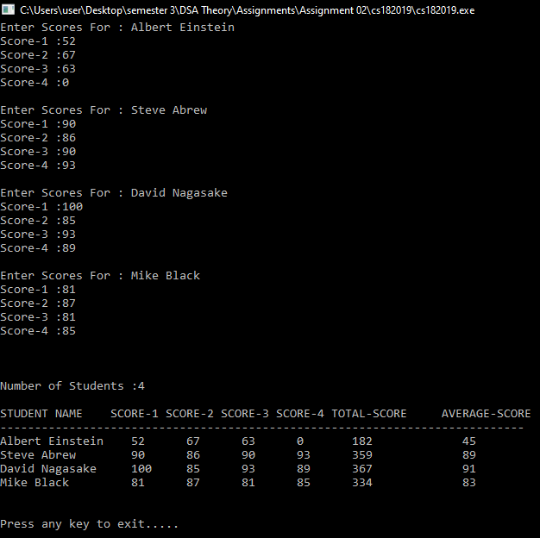

X --------------------------------------------------------------------------------------------------------------------------------------X

MUHAMMAD DANISH | CS182019 | 3B . **COURSE INSTRUCTOR**: Miss Aneela Nargis